Mikhail Alferov
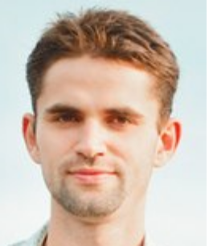
Java Developer Position

Mikhail Alferov
Date of Birth: 21st December 1986
Mobile: +380673382753
E-mail: alferovmikhail@gmail.com

Skills:
Programming language: Java. Groovy.
Framework: EJB. Spring. Spring integration. Hibernate. IBM ESB. Swagger. GWT.
DB: Oracle
VCS: SVN. Git.
Build automation tool: Maven. Ant. Gradle.
Application server: JBoss, Websphere

Education:
2003-2007
Kharkiv National Polytechnic University. Automation and Instrumentation Department. Specialty: “Applied Physics”. Got Bachelor’s degree with honors.
2007-2009
Kharkiv National Polytechnic University. Economics Department. Specialty: “Innovation management.” Got Master's Degree.

2014 (April-September)
Completed a course of Java SE 7 Programming (oracle-academy.org.ua).

Employment history:
During the period from 2008 till 2014 worked in the field of trade and in advertising business.
Since November 2014 I work for CS as a Java developer. I create software for banking sector.
My main duties are: the development of new application modules, and support of existing ones.
I integrated several credit card processings and made an integration with the providers of different services such as iPay, Profix, Portmone. In most cases I used SOAP protocol, and REST was also applied.
Modules were written either with EJB container or Spring. Framework Spring Integration was actively used in these projects. From UI frameworks I have an experience with GWT; this framework is used in our
modules for creating administration consoles.

Communication with DB was carried out either with the help of Spring JdbcTemplate or Hibernate.

Modules were written on Java and Groovy languages. Maven, Ant and Gradle were used for building these projects.

The last project was written for IBM ESB, so I have a development experience with the IBM Integration Toolkit.

Knowledge of foreign languages:
English – intermediate
Russian – native
Ukrainian – native.

Marital status: married, 1 child
Personal skills: I am an organized, communicative, easy trained, disciplined, accurate and responsible person. I am ready for new challenges, and will be glad to learn something new
Interests and hobbies: Football. Fishing.

